IN-SYNC Group
DR Guide – DR Site Users
Version 3.0

Prepared by: Ben Richardson, Network Support Specialist
Date: 25/02/2019

Contents
The Disaster Recovery Site 4
Directions 5
FROM M4 5
FROM A4 5
Before leaving 6
On Arrival 7
Support? 8

The Disaster Recovery Site
Address:
MFG UK Limited
Unit 4a Theale Lakes Business Park Moulden Way
Sulhamstead
Berkshire RG7 4GB
Telephone 0118 9148 800

The contacts for MFG are as follows:
Mark Flinders (Owner): 07785 720 222
Ryan Pulsakowski (Technical Director): 07976 561 854

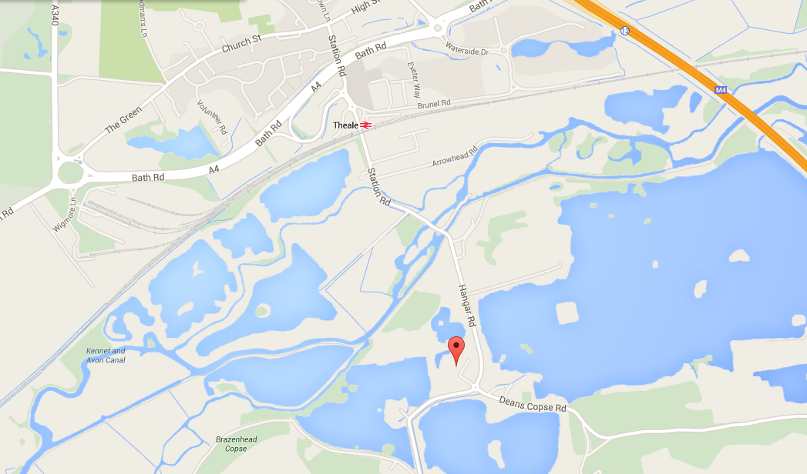

Directions

FROM M4
Leave at JUNCTION 12:
Take the A4 signposted Theale
Proceed to the roundabout and take 1st exit (signposted Arlington Business Park and Commercial Estates)

At the next roundabout take 3rd exit
At roundabout/T-junction turn right (signposted Station)
Proceed straight (with railway on your left and commercial estate on your right)
At roundabout, take left turn and proceed over Railway Bridge at Theale Station
Continue on this road, over the swing bridge
Theale Lakes Business Park will be found in approximately 400 yards on the right hand side

FROM A4
NEWBURY:
Proceed to the roundabout just before M4
Take exit signposted Arlington Business Park, etc
Follow directions as above

Before leaving

If you are leaving from the office please ensure you take a guide that can be issued to you by IT, if you do not already have the latest copy.

If you are leaving from home then please take your copy of the guide with you or if you don’t have it you will get the relevant information when you get to site, however if it is not available to you than you can download it from the following:
https://goo.gl/PuL42v

On Arrival
On arrival at MFG please make sure you let the staff at MFG know you are from Sprite and are here because of a Disaster or DR Test at the main office.
MFG will then direct you to the boardroom whereby you will be given a laptop, USB headset and another user guide. The guide will instruct you on what to do on the laptop to get started.

Support?

If you are having any issues with the system while working at the DR site you will need to contact one of the members of IT who will be onsite. Further assistance can be gained by speaking to a member of the MFG team

For any usual queries that your line manager can deal with contact your DR Representative manager as below:

Operations & Payroll – Carmen Irvine - 07826 063108

