IN-SYNC Group
DR Guide – Home Users
Version 3.0

Prepared by: Ben Richardson, Network Support Specialist
Date: 25/02/2019

Contents
Requirements 4
How to connect 6
Logging into Terminal Server (DR Site): 6
Phone System Access: 15
Starting the DR Phones 19
Who to contact 21

Requirements

These are the requirements needed in order for you to be able to work from home and connect to the DR site. These will be checked periodically with you.
If these have been checked recently you can skip these steps.

Windows 7 or windows 10 (laptop/PC) -

Internet Explorer 9 or higher – This can be checked by opening Internet Explorer, then clicking the Tools button () or help menu then about internet explorer. You will then see the prompt below:
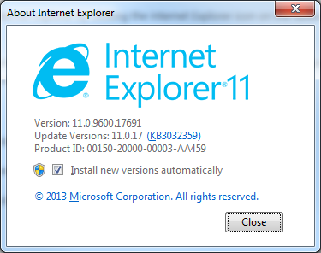
Internet connection of at least 2Mb/s – You can check this by going to http://speedtest.net and running the test by clicking “Begin Test.” The blue mark in the picture below is a minimum to ensure a reliable connection.
Please note if you are a SKY Broadband customer then you will not be able to participate due to incompatibilities with SKY network and the phone software.
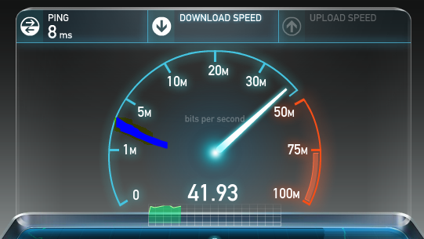
When the test completes you will see a dialog like below:
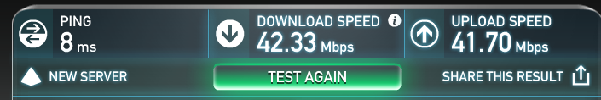
As long as the download speed is above 2Mbps you should not have any access issues.

These requirements will be checked with you at regular intervals to make sure that you will be able to connect from home, and make sure you have everything you need in the event of a DR.

How to connect
You will be assigned a DR Login and as such will be issued a separate document with your login details.

Logging into Terminal Server (DR Site):
- Open internet explorer
- Click the Tools button () at the top right hand side of the screen
- Click on internet options
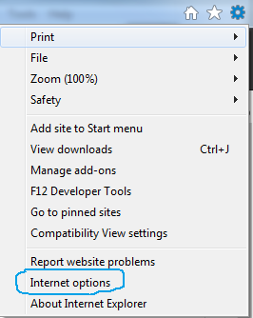
- Change the tab to security
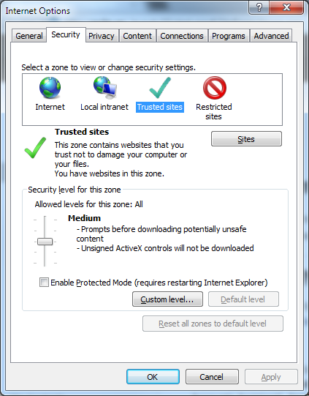

- Click trusted sites
  - Then click sites:
- You will need to add the following address in the box as below:
  - https://drvpn.mfghosted.com
  - Do not add any extras or remove any already in the list.
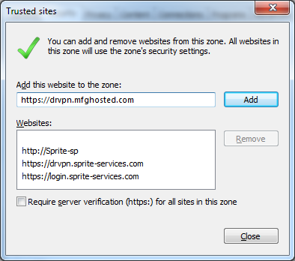
- Press add and then close
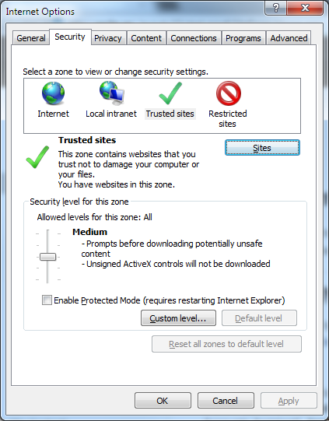
- Then press OK

- You will now need to browse to the following site using Internet Explorer: https://drvpn.mfghosted.com:4431
  - If you see the following screen:
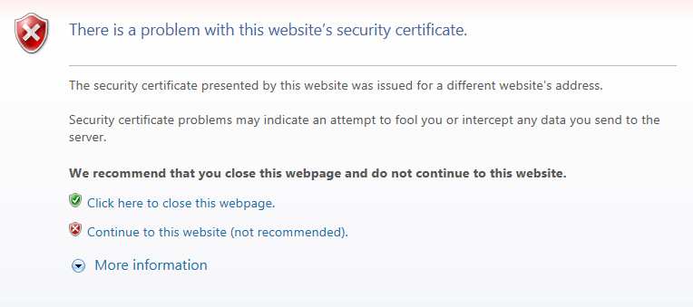
  - Click on continue to this website
- You will then be presented with a login screen as below:
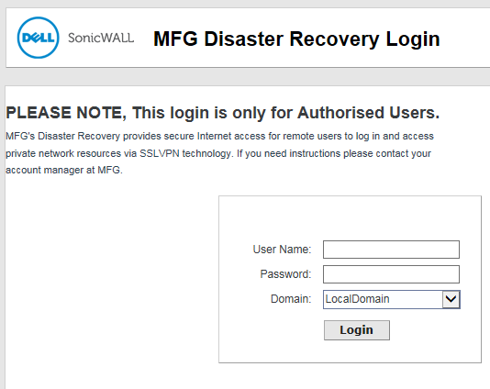

Your login details are provided on a separate handout
Should you lose this or in the event whereby you are at home already and been told to work from home you will be able to get access to the login information by speaking to a manager or IT.
- Once logged in; you will then be shown the following screen:
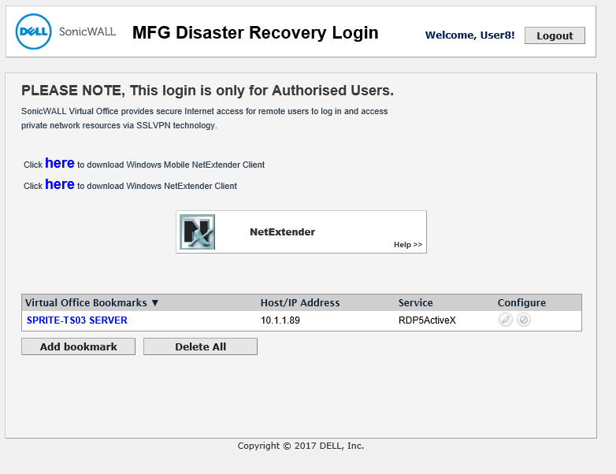

- You should see a connection for Sprite-TS03 under the Virtual Office Bookmarks.
- Click on it
- When logging in you may be prompted to allow an “Active-X Plugin” similar to below:
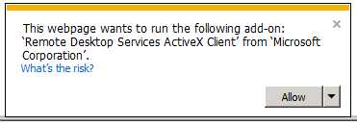
- If so; you want to allow this. You may then be prompted for an addon to be installed
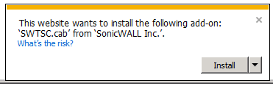
- Again you want to install this.
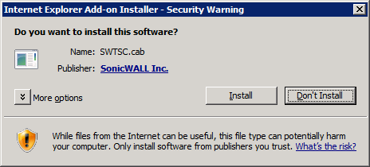
- Once installed you will be prompted with the following screen:
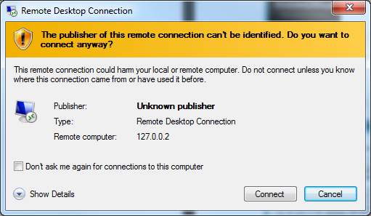
- Click connect
- A login prompt will appear:
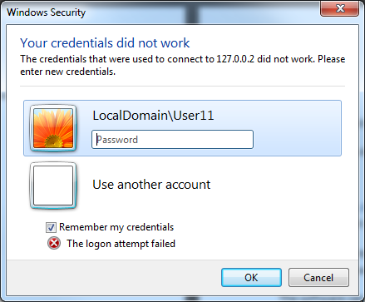
- Click use another account and type in your usual account name for example:
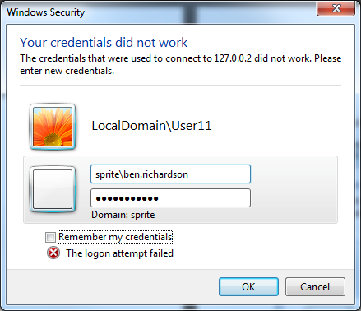
Sprite\Ben.Richardson
Followed by your password
- Make sure to untick the remember my credentials box
- You will now be logged into the Terminal server and able to work with any systems like usual from here.

Phone System Access:

Currently the Phone system will support 5 users. These 5 users are in the operative support team.
If you are not part of the customer service team you can skip the phone setup below.
To login to this system you will require a Windows PC, Headset and the DR Phone software.
If you have a company laptop this should be pre-installed for you, if it is then proceed to the next steps highlighted in “Starting the DR Phones” however if it is not installed please follow the steps below:
- The next steps should be performed on your laptop, so first we must make sure we have minimized the terminal server. This can be achieved by clicking the minimize icon as shown in the top blue bar
- The software can be downloaded from:
- https://xsp.unlimitedhorizon.co.uk/dms/bc/pc/Horizon.win.21.5.3.103.exe
- Once downloaded open the installer
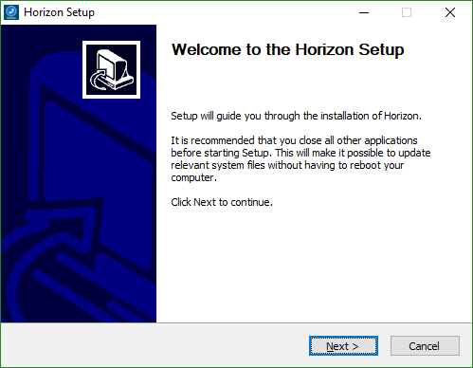
- Click next
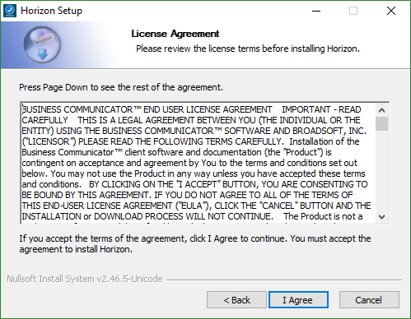
- Click I agree 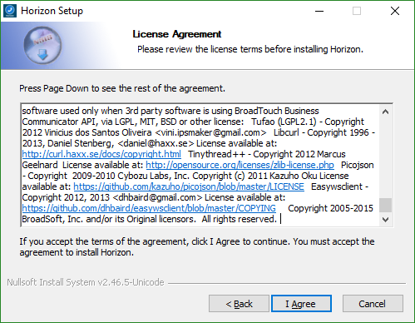
- Click I agree

- Untick Always run Horizon when the system starts.

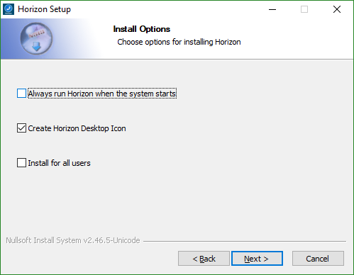
- Click next
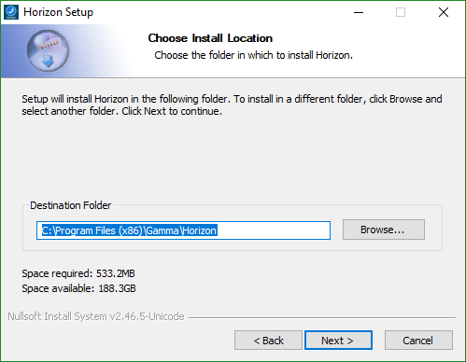

- Click install 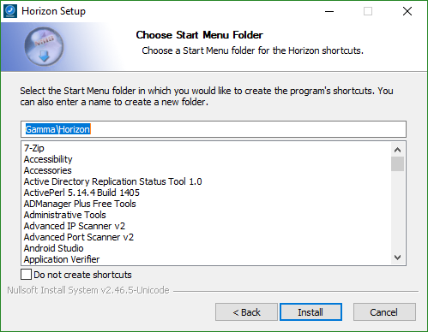
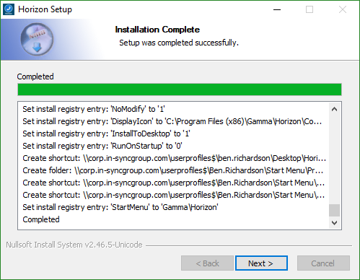
- Once the install has finished click next
- Then finish, the horizon softphone client will now run.

Starting the DR Phones
Look on the desktop for the following shortcut:
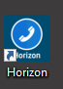
Or if it is not on your desktop go to start all programs / all apps Gamma
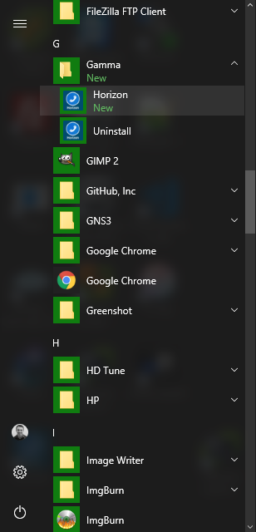
Run it and then enter your phone login details when the following screen appears
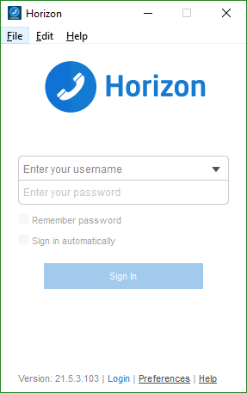

Your login username will follow the below example:
Ben.richardson@in-sync.ltd

Your password was sent to you via personal e-mail and can be reset should you need it.
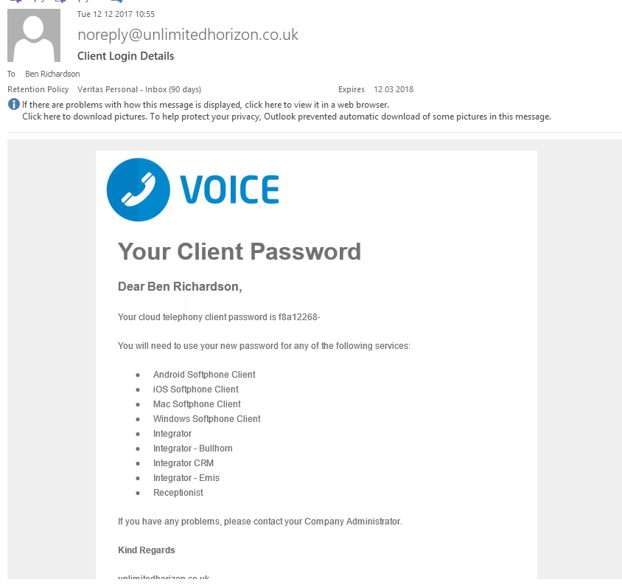

Once logged in you will see the following screen:
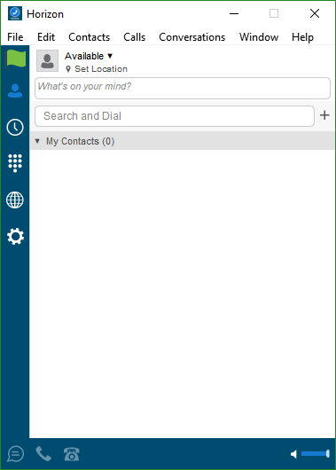
From here you can answer calls and make calls.

Who to contact
If you are having any issues with the system while working from home please contact one of the following members of IT:
IT – We will assist you as much as possible remotely
Ben Richardson – 07588771976
David Woods – 07876203191
Thomas Maddox – 07969028324
If you have a company laptop; then you do not need to install anything, just go to start All programs IT Remote Support

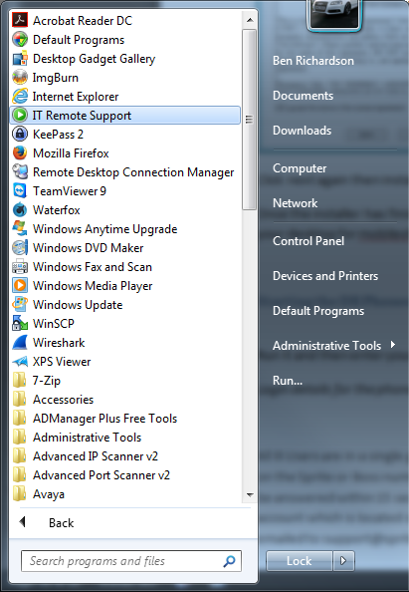

If you do not have a company laptop and would like assistance follow the steps below:
- Go to: https://goo.gl/oKxYk6
- Click on TeamViewerQS
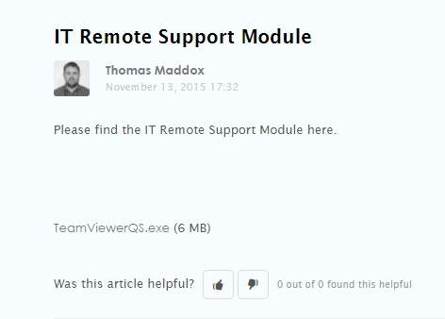

- When the download has saved you will need to run it.
- This will then open TeamViewer which you should be familiar with as it is the one we use at the office.
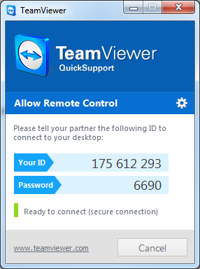
- Please provide us with your ID
  - If you manually installed this due to not using a corporate laptop we will also need the password.

If we cannot assist you we will advise you who else to speak to.
For any usual queries that your line manager can deal with contact your DR Representative manager as below:

Operations & Payroll – Carmen Irvine - 07826 063108

