IN-SYNC
Terminal Server

Prepared by: Ben Richardson, IT Network Support Specialist
Date: 07/08/2019
Open remote desktop connection from the start menu
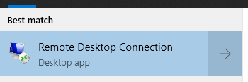
When the Remote desktop connection window opens type the following name in the computer box: in-ts
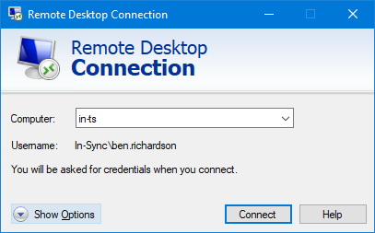
Press connect

If you get a certificate error like below:
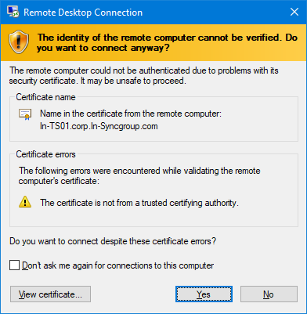
Tick the don’t ask me again box and press Yes
You are now connected to one of the terminal servers:
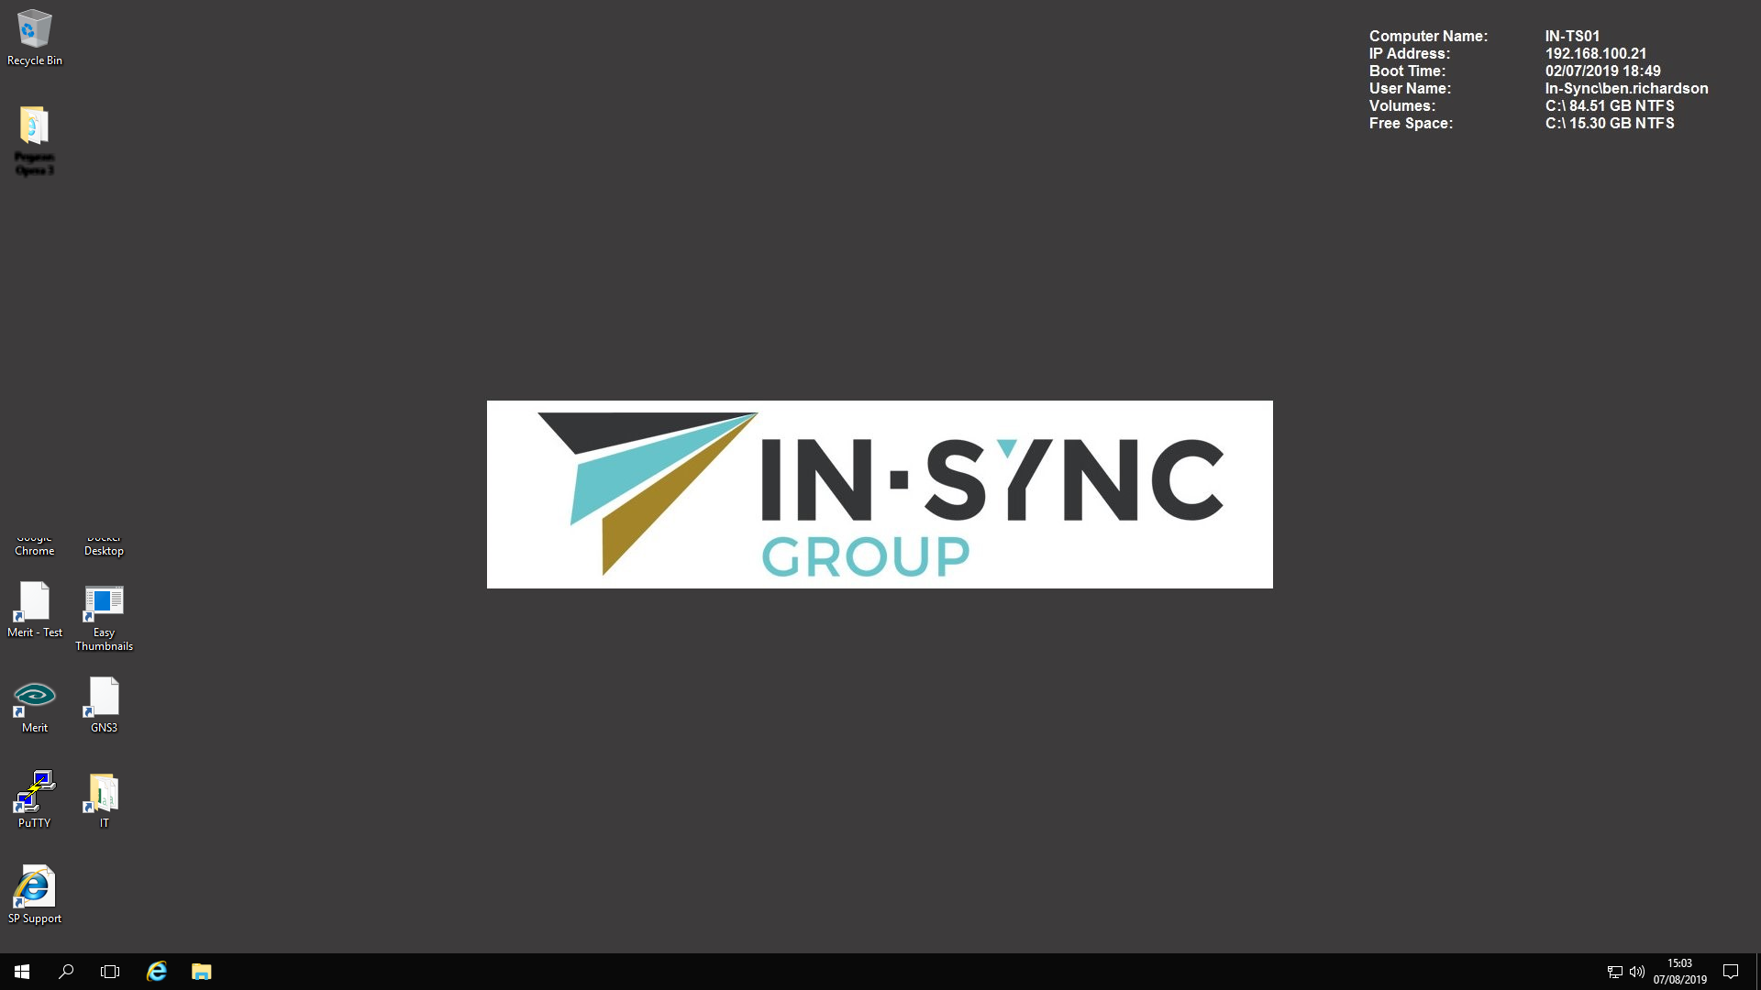
From here you can open “Adobe Acrobat XI Standard” to convert PDF to Excel/Word etc
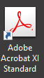
or open Visio.
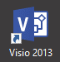

When you wish to save a PDF as a word or excel document the following must be done
When saving the PDF go to Save As Other and select the format you wish to save the document as

Once finished please ensure you sign out rather than “disconnect”, this can be done by clicking start then your photo and sign out or by clicking start and typing “logoff”

This ensures the server is not left with multiple people logged in slowing it down for others who may be working from home.

